bibliographic Information ツ

Author(s):
Xia, Pengxiang, et al.
Title of article or book (if a chapter in a book, put the chapter # and title here, and put the title of the book in “Title of publication”):

Title of publication, including Vol., Num., date (if article in magazine, newspaper, or journal):

Comparison of 3D SLAM for Quadrupedal Robot-Based Scanning

Page numbers (if article in magazine, newspaper, or journal):

Publisher:

Date published:

URL (if applicable):
https://ascelibrary.org/doi/abs/10.1061/9780784483893.130
MLA citation:
Xia, Pengxiang, et al. ‘Comparison of 3D SLAM for Quadrupedal Robot-Based Scanning’. Computing in Civil Engineering 2021, pp. 1059–1066, https://doi.org/10.1061/9780784483893.130.

Direct quotes: Include Page #s (For each quote, provide some context and/or analysis; you may also want to re-state the information in your own words. Quotes from your sources, and your understanding of them, will make up the bulk of your literature review)
- In general, depending on the source of data capture, 3D SLAM can be categorized into depth camera SLAM and LiDAR SLAM. The former one uses a depth camera to generate range information while the later one is equipped with a LiDAR scanner. P1
- 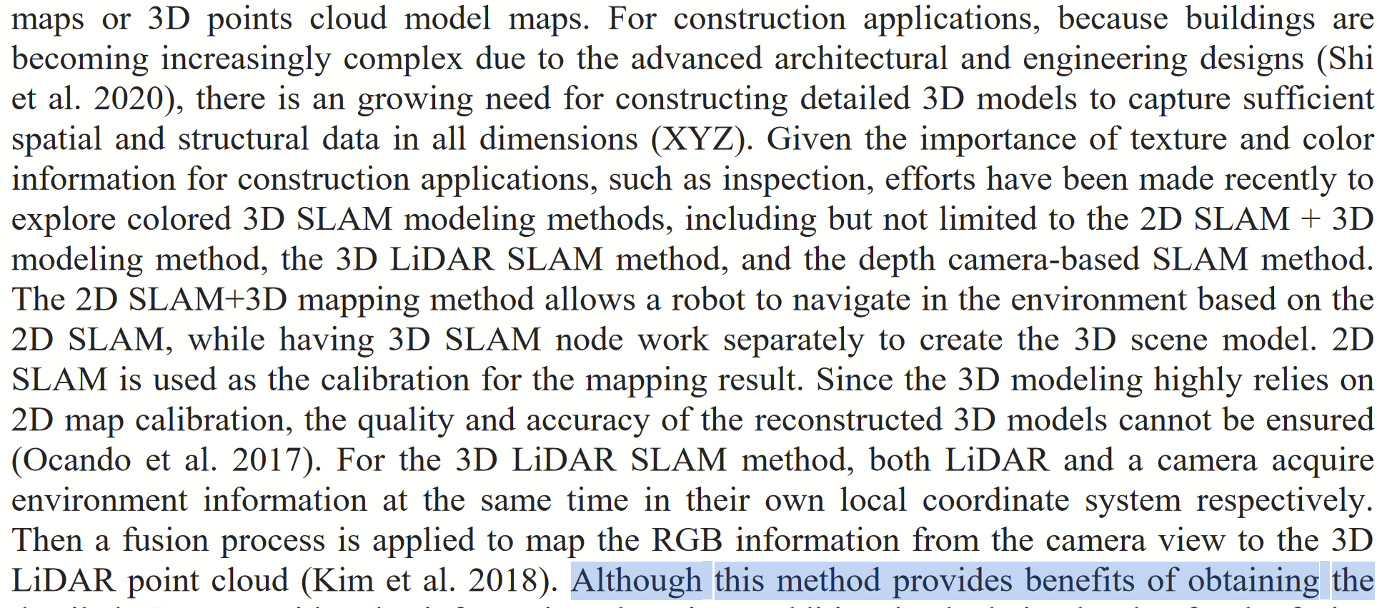p2
- 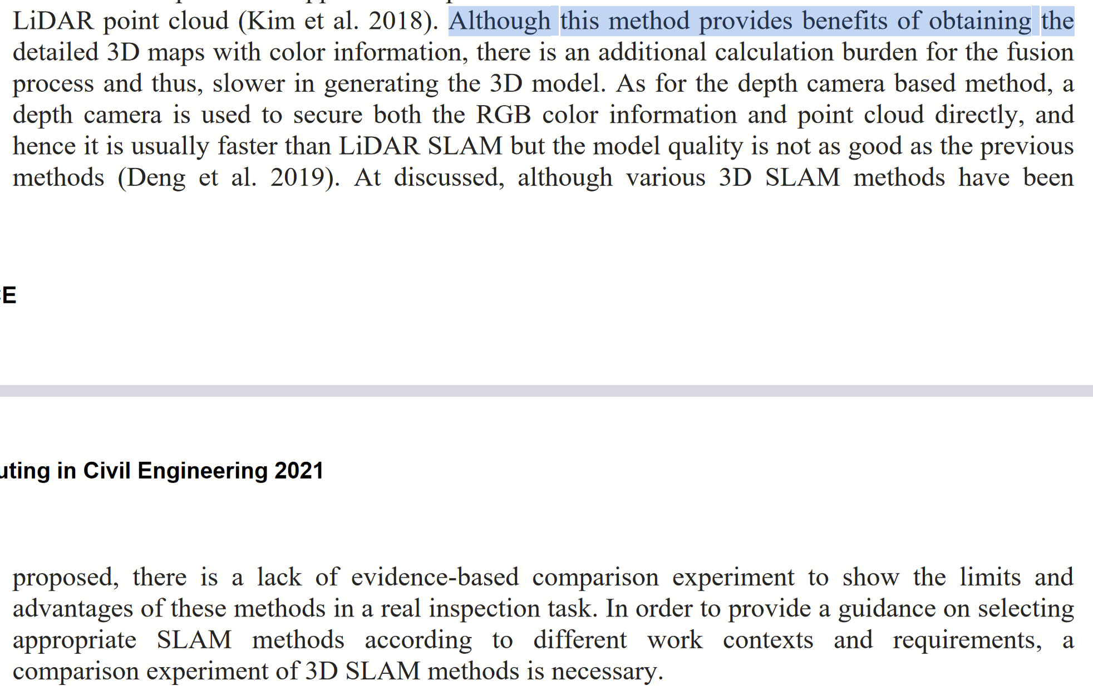p2-3
- 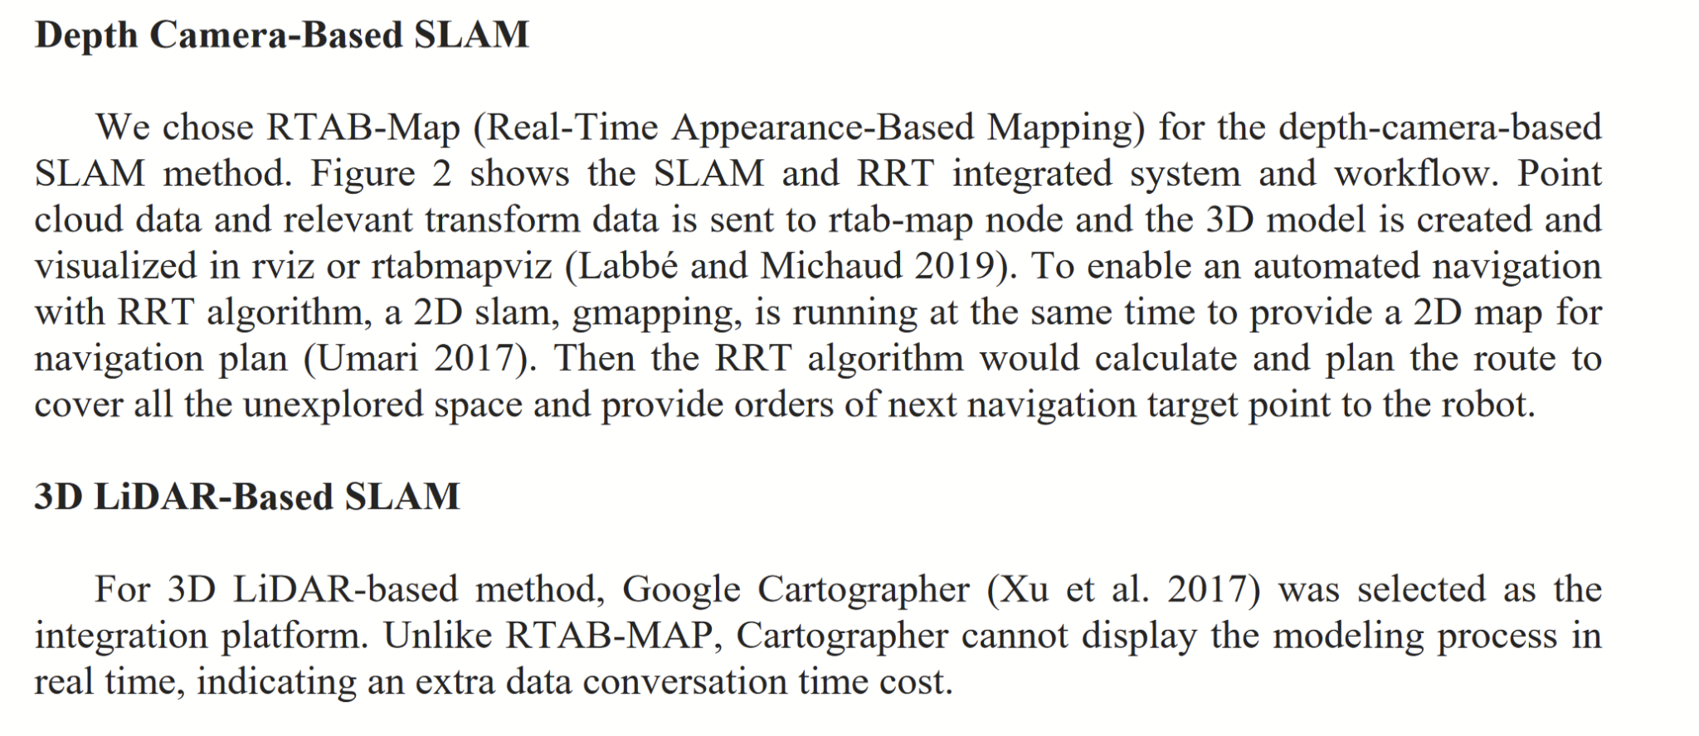p3
- 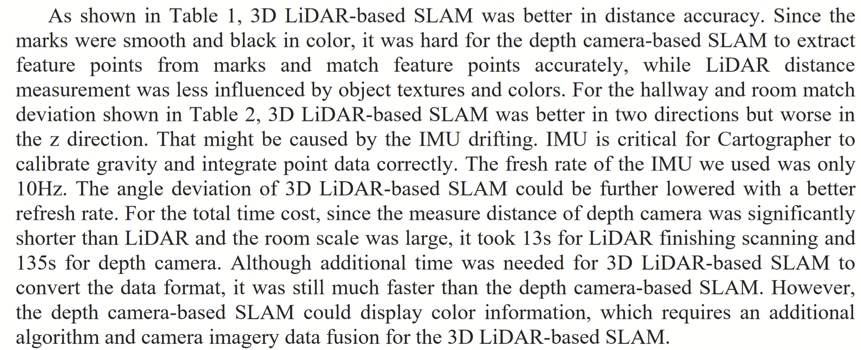p5
- 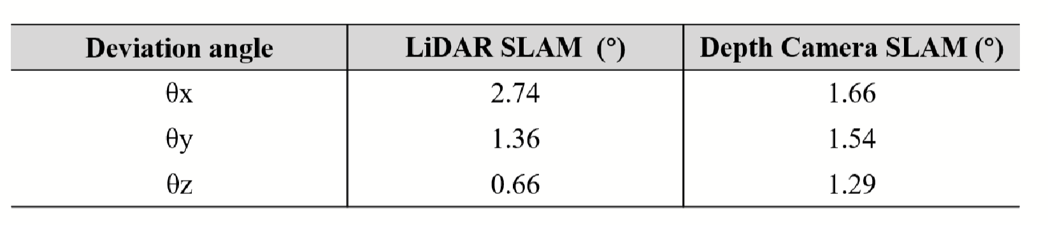p6

Paraphrased Notes: Include Page #s (This is a space for you to track the flow of information, and the ways in which the article engages with other works.)

Summary of Source (2-4 sentences)
There for sure are 2 different methods of mapping. RGBD is better for detail but takes way longer, while LIDAR gives higher precision and is faster but has a lack of information, notably the rgb.

Does this help me answer my question? Why or why not?
Yep! Talks about sensors which are a pretty important part of my question

Lingering Questions

Connections to other sources

